* Temperature Sensor:-

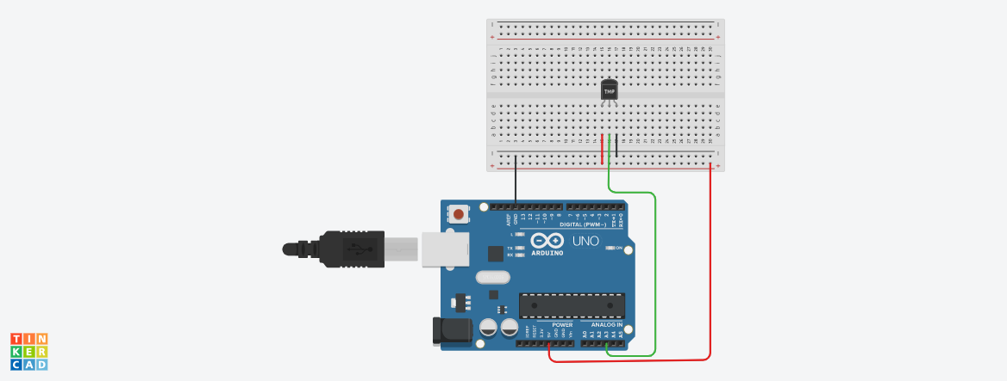

**Circuit diagram**

* **Description :-**

This project is working on Temperature Sensor. Like in this project Temperature Sensor connected with Breadboard & Arduino. We can see the temperature in serial monitor. When we change the temperature then it’s also changed in serial monitor.

* **Application :-** 
  + - * + Measure the temperature rise during the process of curing concrete.
        + Laboratory and testing applications.
        + In Heat Exchanger.
        + In Air conditioner (AC) & Refrigerator
* **Working Principle:-**

The basic principle of working of the temperature sensors is **the voltage across the diode terminals**. If the voltage increases, the temperature also rises, followed by a voltage drop between the transistor terminals of base and emitter in a diode.

* **Circuit Connection :-**

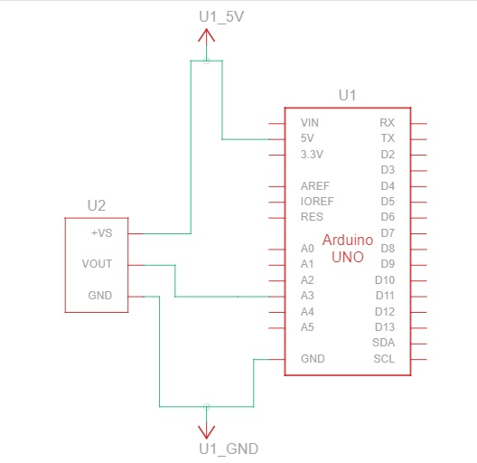

* Component List :-

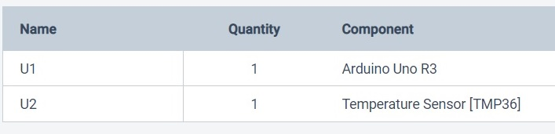

* **CODES :-**

// C++ code

//

int TMP = 0;

void setup()

{

pinMode(A3, INPUT);

Serial.begin(9600);

}

void loop()

{

TMP = (-40 + 0.488155 * (analogRead(A3) - 20));

Serial.println(TMP);

delay(10); // Delay a little bit to improve simulation performance

}

* **BLOCKCODES :-**

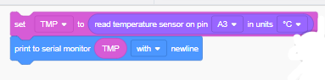

* **SERIAL MONITER :-**

